**Name:**

**Procedure for making a Dye-Sensitized Solar Cell**

**Part 1**

1. Take one piece of conductive glass and ensure that the conductive side is facing up; do this by using the multimeter probes to measure resistance across two points on the glass surface. Ensure that the multimeter is set to resistance mode (Ω) on any setting. (*Carefully handle the sides of the glass electrodes and avoid touching the faces of the electrodes.*) If no resistance is measured turn the electrode over and measure again. Typical resistances should be around 10 – 30 ohms.
2. Tape the electrode down to a clean, sturdy surface so that the tape masks off ~1.5 cm (bigger is better) down along the length of the electrode (Figure 1a). This will create a masked off area on the electrode where the TiO2 paste will be spread.
3. Using a pipette, drip a few drops of the TiO2 solution in the center of the plate and immediately squeegee the solution down and up once with the side of the pipette. Aim for an even coating of the paste. If a TiO2 film does not coat the entire exposed surface, quickly drip a few more drops of TiO2 on the exposed areas and re-squeegee the entire film. Allow the electrodes to dry, undisturbed, for a few minutes.

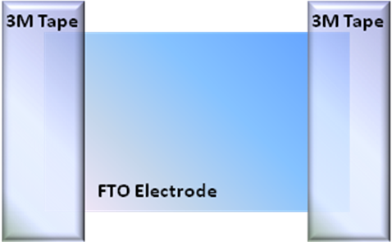 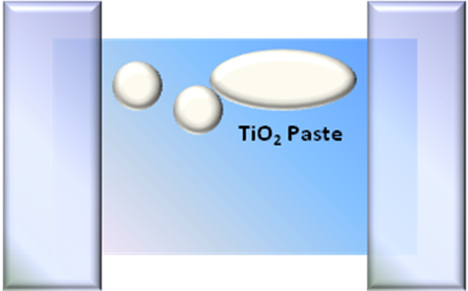 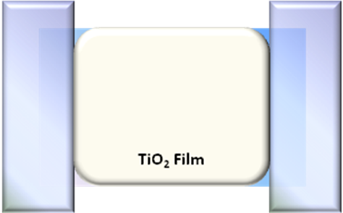

***Figure 1.*** *Steps for depositing TiO2 paste.*

1. Remove the Scotch tape from the dried TiO2 electrode.
2. *A teacher will take the electrode to anneal (dry) on a hotplate.*

**Part 2**

1. Prepare the dye by thoroughly (but gently) crushing 1 blackberry in a plastic bag by squeezing the outside of the bag.
2. Take the TiO2 coated glass electrode and place it into the blackberry juice in the bag for ~5 minutes. (*Use tweezers or tongs to handle the electrode.*) Be sure that the electrode is completely covered. The white TiO2 paste should turn completely purple so there is no white left.
3. Rinse the blackberry pieces off the electrode with water and then isopropanol, catching the drippings in a glass beaker. Allow it to dry for 10 min.
4. While you wait, take your other piece of conductive glass—this will be the *counter electrode*. Use a multimeter to find the conductive side (see step 1). Use a pencil to coat the entire surface with graphite (pencil lead).
5. Assemble the dyed TiO2 electrode with the counter electrode using 2 binder clips to form a sandwich. Make sure the graphite-coated electrode covers the purple dyed TiO2 surface and avoid overlapping the bare glass electrodes (the part you covered with tape). The graphite-coated electrode should line up with the TiO2 line but is offset so that an alligator clip can be attached to each individual electrode. The binder clips go on the edges that are not offset. (see picture below)
6. Carefully add the iodide/triiodide (I-/I3-) electrolyte solution with a pipette to the seam of the two electrodes. Capillary action will pull the solution in and the space between the glass electrodes should turn slightly yellow and be entirely wetted by the solution.
7. To test your solar cell, clip the positive terminus (red) of the multimeter probe to the graphite electrode and negative terminus (black) to the TiO2 electrode using alligator clips.

Description: :Outreach:J from J:docs:DSSC mod:Picts for instructions:pict of cell.pdf

|  |  |  |
| --- | --- | --- |
| **Data Table (include units for voltage and current)** | | |
|  | Room light | Outside light |
| DSSC  Voltage |  |  |
| DSSC  Current |  |  |
| DSSC  Power |  |  |
| *Silicon Cell*  *Voltage* |  |  |
| *Silicon Cell*  *Current* |  |  |
| *Silicon Cell*  *Power* |  |  |